Project Design Phase-II
Data Flow Diagram & User Stories

Date | 31 January 2025
Team ID
Project Name | AI Blog Nest API
Maximum Marks | 4 Marks
Data Flow Diagrams:
A Data Flow Diagram (DFD) is a visual representation of the information flows within a system. It shows how data enters and leaves AI Blog Nest API, what changes the information, and where data is stored. The Level-1 diagram on the next page uses the Gane-Sarson notation:
- External entities (double rectangles): people or systems outside the API (Admin, Author / Reader, Email Service, LLM Provider API).
- Processes (rounded boxes): numbered steps that transform data: 1.0 Authenticate & Authorise User, 2.0 Manage Blog Posts, 3.0 Generate & Edit AI Content.
- Data stores (open-ended boxes): D1 Users, D2 Posts, D3 Post Versions (PostgreSQL) and D4 AI Cache (Redis).
- Data flows: arrows labelled with the data that moves, such as JWT tokens, post data, AI prompts and generated text.
How data moves: an author logs in (1.0) and receives a JWT; creates or edits posts (2.0), which are saved in D2 with a version in D3; asks for AI help (3.0), which checks the cache (D4), calls the LLM provider when needed, and returns the text or saves it as a Draft through 2.0.

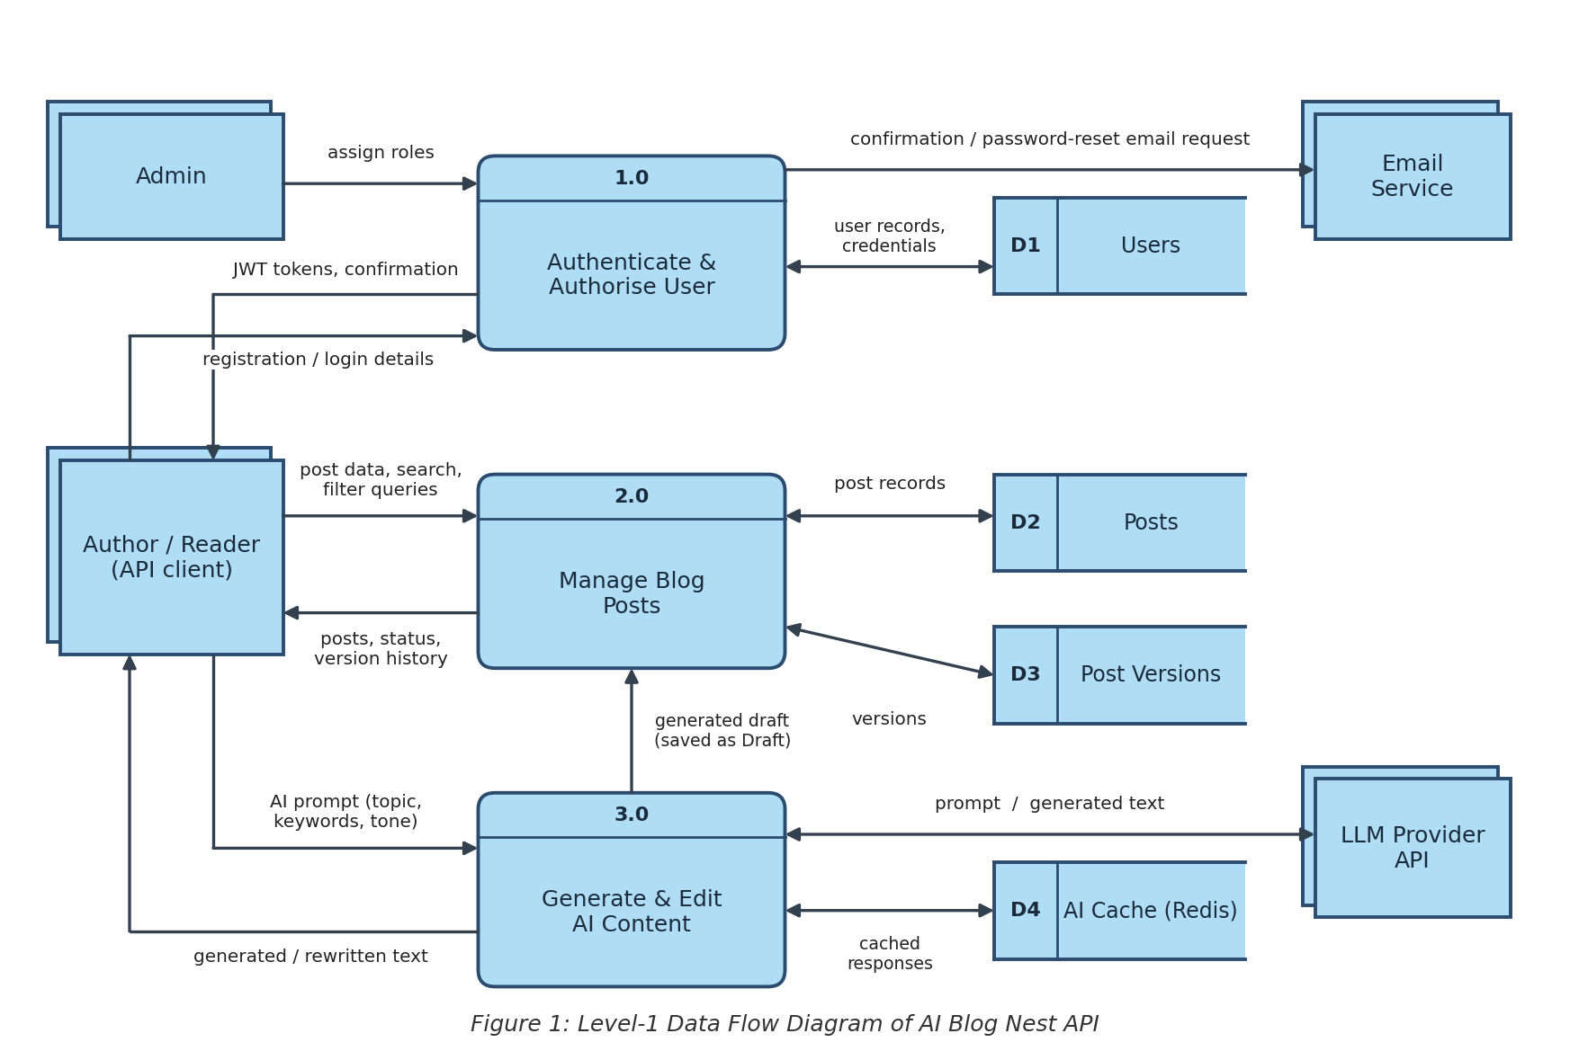
User Stories
Use the below template to list all the user stories for the product. User story numbers, priorities and releases match the product backlog in the Project Planning document.
User Type | Functional Requirement (Epic) | User Story Number | User Story / Task | Acceptance criteria | Priority | Release
Developer | Project Setup | USN-1 | As a developer, I can set up the NestJS project with environment config, PostgreSQL (TypeORM) connection and Docker so the team can build on a common base. | Project starts with one command (Docker Compose); app connects to the database; health endpoint returns OK. | High | Sprint-1
Author / Reader | Authentication | USN-2 | As a user, I can register by entering my email, password and confirm password. | Valid details create an account (HTTP 201); duplicate email or mismatched passwords are rejected; password is stored hashed. | High | Sprint-1
Author / Reader | Authentication | USN-3 | As a user, I will receive a confirmation email once I have registered. | Email arrives after registration and contains a working confirmation link. | Medium | Sprint-1
Author / Reader | Authentication | USN-4 | As a user, I can log in with email and password and receive JWT access and refresh tokens. | Correct credentials return both tokens; wrong credentials return 401. | High | Sprint-1
Administrator | Authentication | USN-5 | As an admin, I can assign roles (Admin, Author, Reader) and the API restricts endpoints by role. | Role change applies on next login; a Reader cannot create posts (403). | High | Sprint-1
Author | Blog Management | USN-6 | As an author, I can create a blog post (saved as a draft) with title, content and cover details. | Post is saved with status Draft and me as owner; missing title returns 400. | High | Sprint-1
Reader | Blog Management | USN-7 | As a reader, I can view a list of published posts and open a single post. | Only Published posts are listed; a post opens by ID; unknown ID returns 404. | High | Sprint-1
Author | Blog Management | USN-8 | As an author, I can update or delete my own posts. | I can edit and delete my posts; editing another author’s post returns 403. | High | Sprint-1
Author | Blog Management | USN-9 | As an author, I can move a post through Draft, Published and Archived states. | Status changes are saved; only Published posts are public. | High | Sprint-2
Author | Blog Management | USN-10 | As an author, I can organise posts with categories and tags. | A post can have one category and several tags; posts can be filtered by them. | Medium | Sprint-2
Reader | Blog Management | USN-11 | As a reader, I can search, filter, sort and paginate posts. | Results match the keywords and filters, are sorted as requested, and include page metadata. | Medium | Sprint-2
Developer | AI Content Generation | USN-12 | As a developer, I can integrate an external LLM API through a provider-agnostic AI service module with prompt templates. | LLM provider can be changed by configuration only; calls use prompt templates; timeouts and errors are handled. | High | Sprint-2
Author | AI Content Generation | USN-13 | As an author, I can generate a full blog draft by giving a topic, keywords and tone. | Response has title, body, summary and tags; a draft is saved; an empty topic returns 400. | High | Sprint-2
Author | AI Content Generation | USN-14 | As an author, I can get AI-suggested titles, a summary and a meta description for my post. | Several title options, a summary and a meta description are returned. | Medium | Sprint-2
Author | AI Content Generation | USN-15 | As an author, I can get AI-suggested tags and categories for my post. | Suggested tags and a category are returned; I can accept or ignore them. | Medium | Sprint-2
Author | AI Content Generation | USN-16 | As an author, I can rewrite selected text in a different tone (formal, casual, technical). | Text is returned in the requested tone and keeps its meaning; an unsupported tone returns 400. | High | Sprint-3
Author | AI Content Generation | USN-17 | As an author, I can expand or shorten a section using AI. | Expanded text is longer and shortened text is shorter; key points are kept. | Medium | Sprint-3
Product Owner | Performance & Security | USN-18 | As a product owner, I want repeated AI requests cached in Redis to reduce cost and response time. | An identical request returns the cached result without calling the LLM; cache entries expire after a set time. | Medium | Sprint-3
Product Owner | Performance & Security | USN-19 | As a product owner, I want rate limiting on AI endpoints to prevent abuse and control cost. | Requests above the limit get 429 with retry information; the limit is configurable. | High | Sprint-3
Author | Blog Management | USN-20 | As an author, I can view a post’s version history (including AI edits) and roll back to a previous version. | Each save, including AI edits, creates a version; rollback restores the chosen version. | Medium | Sprint-3
Author / Reader | Authentication | USN-21 | As a user, I can reset a forgotten password through an email link. | Reset link is emailed, works once and expires; the new password works and the old one is rejected. | Medium | Sprint-3
Author / Reader | Authentication | USN-22 | As a user, I can register and log in through my Google account. | Google sign-in creates or matches an account and returns JWT tokens. | Low | Sprint-3
Developer | Documentation | USN-23 | As a developer, I can read interactive Swagger (OpenAPI) documentation for every endpoint. | Swagger UI lists every endpoint with request and response schemas and accepts a JWT. | High | Sprint-3
Developer | Quality & Testing | USN-24 | As a developer, I want unit tests for the auth, posts and AI service modules. | Unit tests for the three modules run and pass in the CI pipeline. | High | Sprint-4
Developer | Quality & Testing | USN-25 | As a developer, I want end-to-end tests covering the main API flows. | End-to-end tests for register, login, post and AI flows pass against a test database. | High | Sprint-4
Developer | Quality & Testing | USN-26 | As a developer, I want global validation, exception filters and logging for consistent error responses. | All errors return one JSON format; requests and errors are logged. | Medium | Sprint-4
Third-party Developer | Integrations & SEO | USN-27 | As a third-party developer, I can use an API key to access the API from my own application. | A valid key grants access; an invalid or revoked key returns 401. | Low | Sprint-4
Author | Integrations & SEO | USN-28 | As an author, I get auto-generated slugs and AI keyword suggestions to improve SEO. | A unique slug is created from the title; keyword suggestions are returned. | Low | Sprint-4
Developer | Deployment | USN-29 | As a developer, I can build and test the project automatically through a CI/CD pipeline. | Every push runs build and tests; failing tests block the merge. | High | Sprint-4
Product Owner | Deployment | USN-30 | As a product owner, I want the API deployed to a cloud environment with production configuration. | API is reachable over HTTPS; secrets are kept outside the code. | High | Sprint-4

